ITCS241 Database Management System
Project 01

SoundCloud

Member
6388003 Phuriwat Angkonndittaphong
6388012 Rujiphart Charatvaraphan
6388185 Bunradar Chatchaiyadech
6388187 Waranat Deepradub

Section 1 Group 6

Presented to
Dr. Siripen Pongpaichet
Dr. Jidapa Kraisangka

Sep 12, 2021

CONTENTS
page

SoundCloud History and Goals 2
Business Overview 4
Business rules and Constraints 6
Reference 9

SoundCloud History and Goals

SoundCloud was founded in 2007 by Alexander Ljung and Eric Wahlforss.The idea to create SoundCloud began when they were both studying at KTH Royal Institute of Technology in Sweden. Then, it has grown to be one of the most extensive music streaming services. There is both free and paid membership, and it is available for desktop and mobile devices. There are many features such as uploading, promoting, sharing, and streaming audio. It has influenced the music industry because of its success. Many artists have used it to launch or advance their music, and many investors support it.

History
- In August 2007, SoundCloud was established in Berlin by Alexander Ljung, Swedish sound designer, and Eric Wahlforss, a Swedish electronic musician.
- In October 2008, the website was launched. Its first purpose is to allow musicians to collaborate by facilitating the sharing and discussion of recordings. It has become a publishing tool for music sharing. As a result, it began to challenge the dominance of Myspace as a platform for musicians to publish their music.
- In April 2009, it received €2.5 million Series A funding from Doughty Hanson Technology Ventures.
- In May 2010, There were one million users.
- In January 2011, it had raised US$10 million Series B funding from Union Square Ventures and Index Ventures.
- In June 2011, There were five million registered users and investments
- In January 2012, There were 10 million registered users.
- In May 2012, there were 15 million users, and site usage increased by 1.5 million users per month.
- In December 2012, A new APN was released, improving mobile support and adding features such as concurrent listening, site navigation, and creating personal collections. SoundCloud reported that they reach 180 million people per month and 10 hours of uploaded content per minute.
- In March 2014, Twitter partnered with SoundCloud for developing its first integrated music app, but the attempt failed.
- In July 2013, There were 40 million registered users and new 20 million users joined per month.
- In January 2014, it announced that it had commenced licensing negotiations with major music companies.
- In May 2015, Twitter was considering the acquisition of SoundCloud. However, the prospect of the purchase was discounted by the media.
- In September 2016, Spotify announced that it was in talks to buy SoundCloud, but Spotify abandoned its acquisition plans.
- In Spring 2017, SoundCloud was sold after not raising the $100 million needed to support the platform.
- In July 2017, it announced layoffs and the closure of two of its five offices.
- In August 2017, it announced that it reached an agreement on the Raine Group and Temasek investment. Kerry Trainor, a veteran digital media operator, joined the SoundCloud team as Chief Executive Officer, and Michael Weissman joined the SoundCloud team as Chief Operating Officer. Alexander Ljung came to be Chairman of the Board. Eric Wahlforss came to be a Chief Product Officer, and then he transitioned into an advisory role.
- In March 2021, it announced a new pay model for artists, entitled "fan-powered royalties".The income is from the subscription and advertising revenue.

Platforms
- Mobile
There are two mobile apps; the main SoundCloud app is oriented towards streaming, music searching, playlist, and sharing features. In November 2015, a separate app, SoundCloud Pulse, was released for Android and iOS. It allows users to upload and manage their uploads, reply to comments, and view statistics. By the end of 2016, SoundCloud Pulse had over 100 million downloads. And in April 2017, the main SoundCloud was supported in the Chromecast of iOS app.
- Desktop
In January 2011, SoundCloud released the "SoundCloud Desktop app for Mac", but it was discontinued because lack of resources to maintain their new desktop application, the mobile applications, and the web browser at the same time.
In May 2017, it released an application for Xbox One. Unfortunately, it missed a few features, such as the ability to cast a song from an external device and the ability to go forward or backwards in a playlist without using Cortana.
In May 2017, it released the "SoundCloud for Windows (Beta)" desktop application to the Windows 10 Microsoft Store (digital). It solved the problems of the previous one, but there were still missing many core features such as 'repeat' and basic animations. As a result, the app (as of 2020) has not been updated nor changed.

Goals
Their goal is to enable artists and listeners to get the most out of the world's top social sound platform by establishing the SoundCloud forum for go, quick, and accessible online assistance channel for solving problems and sharing experiences.

Business Overview

What is SoundCloud?

SoundCloud is the largest audio discovery and artists community platform and services that supports the independence of artists with over 250 million tracks from 30 artists from 190 countries.
For the artists. Artists can upload audios and share them with artists’ social networks. They can use this platform to promote the new coming tracks, engage with fanclubs and monetize from the provided tracks.
For the listeners. Listeners can search and find any new audios and share the discoveries into their social networks. They can contribute to the artists they favor by commenting, sharing and liking their audio tracks. They can even save unlimited tracks and playlists for the monthly-subscription model.
In the subscription model, there are 3 choices for users.
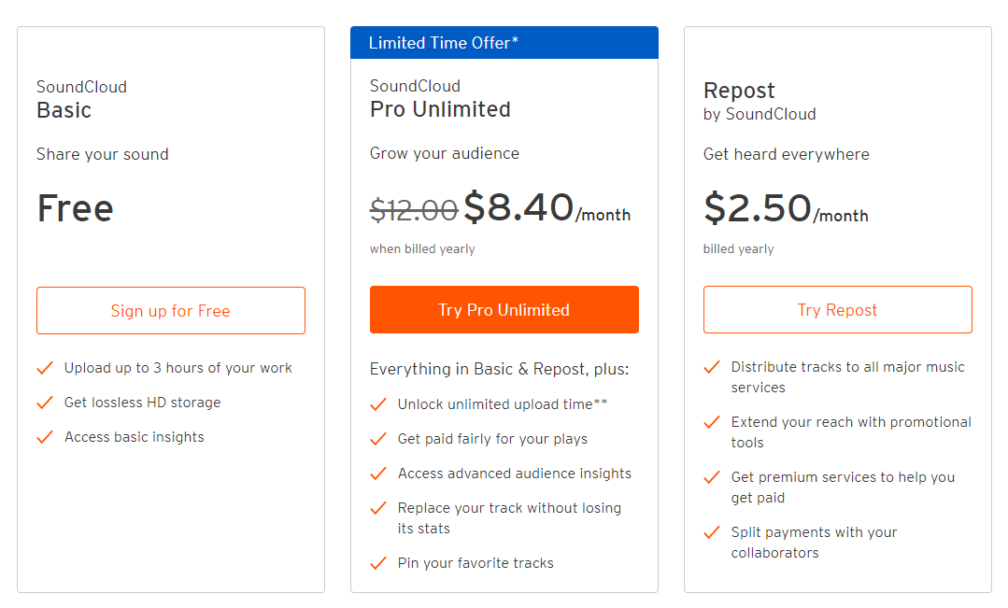
Basic (Free)
- Free user, they can upload audios up to 3 hours
- Lossless HD audio storage for unlimited
- Be able to get some basic insights
Pro Unlimited ($8.40 / month)
- Unlimited upload time
- Be able to monetize by users’ audio
- Be able to get advanced audience insights
- Upload the overlapped audio track without losing its stats
- Mark users’ favorite tracks
Repost ($2.50 / month)
- Can provide tracks to all popular music services
- Promotional tools accessibility
- Unlock the premium services and monetize
- Divide payments transaction with users’ friends

Business rules and Constraints
No. | Rule details | Type of relation
1 | One user may upload many tracks.  One track may store only one user.(unique instance for each user) | 1 : M
2 | Any user may follow many other users. | M : N
3 | One track may be in Many albums.  One album may store many tracks. | M : N
4 | One user may upload many albums.  One album belongs to one user. | 1 : M
5 | One track may have many tags.  One tag may have many tracks. | M : N
6 | One track may have many comments.  One comment can be only on one track. | 1 : M
7 | One user may type many comments.  One comment belongs to only one user. | 1 : M
8 | One user can like many tracks.  One track can be liked by many users. | M : N
9 | One track can be reposted many times.  One repost may have many tracks. | M : N
10 | One user can send many private messages (to other users).  One private message is associated with only a pair of users. | 1 : M
11 | (History)  One user can listen to many tracks.  One track can be listened to by many users. | M : N
12 | One genre is attributed to many forms of music.  One music has only one genre. | 1 : M
13 | (Subscribe to pro)  One user can have many invoices.  One invoice belonged to only one user. | 1 : M
14 | (Subscribe to pro)  One invoice can specify only one subscription  One subscription can be in many invoices | 1 : M
15 | (Donation)  One user can have many invoices.  One invoice belonged to only one user. | 1 : M
16 | (Donation)  One invoice can specify only one subscription  One subscription can be in many invoices | 1 : M
17 | One playlist can have many tracks.  One track can be in many playlists. | M : N
18 | One user can have many playlists.  One playlist belongs to one user. | 1 : M
19 | One user may have many notifications.  One notification belongs to many users. | 1 : M
20 | One user calls the problems to many operators.  One call operator operates many users. | M : N
21 | One user can have many accounts.  One account belongs to one user. | 1 : M
22 | One user can have one user setting.  One user setting belongs to only one user. | 1 : 1

23 | One track may be blacklisted in many countries.  One country many blacklist many tracks. | M : N
24 | One user can block many users. | M : N
25 | One user follows many stations.  One station can be followed by many users. | M : N
26 | One user can report many tracks.  One track can be reported by many users. | M : N
27 | One user may have many transaction details.  One transaction detail belongs to only one user. | 1 : M
28 | One user may search many times.  One search history belongs to only one user. | 1 : M
29 | One playlist may have many tags.  One tag may be in many playlists. | M : N
30 | One user post may have many tracks.  One track can be in many user posts. | M : N
31 | One user may have many activities.  One activity belongs to only one user. | 1 : M
32 | One user can buy a subscription one time per month. | 1 : 1
33 | One track has only one license.  One license associate with many tracks. | 1 : M
34 | Users cannot follow oneself. | constraint
35 | Cannot have duplicate Email for all users. | constraint
36 | Users must subscribe for Pro to monetize their works | constraint
37 | Users must subscribe for Pro to make upload time longer than 3 hours. | constraint
38 | User must subscribe for Pro to access advanced insight | constraint
39 | Users must subscribe for Pro to let listeners download your tracks more than 100 times. | constraint
40 | Users must subscribe for Pro to get responses on a day when they ask for customer services. | constraint
41 | Users must subscribe for Pro to be able to replace track without reuploading. | constraint
42 | A track may have many contributors. | constraint

Reference
Overview

Soundcloud. (n.d.). What is SoundCloud?. Retrieved September 8, 2021, from
https://help.soundcloud.com/hc/en-us/articles/115003570488-What-is-SoundCloud-

Soundcloud. (n.d.). SoundCloud Subscription details. Retrieved September 8, 2021, from
https://checkout.soundcloud.com/pro

History

Insider. (Aug 27, 2015). The fabulous life of SoundCloud cofounder and CEO Alexander Ljung, from
https://www.businessinsider.com/life-of-soundcloud-founder-ceo-alexander-ljung-2015-8#in-2014-soundcloud-caught-the-attention-of-twitter-which-started-making-a-plan-to-buy-ljungs-company-twitter-had-already-tried-to-launch-a-music-product-to-get-people-to-stay-longer-on-the-platform-but-the-attempt-failed-7

Wikipedia. (n.d.). SoundCloud. Retrieved September 8, 2021, from
https://en.wikipedia.org/wiki/SoundCloud

Goals (Vision)

Insided. (n.d.). Case study: SoundCloud, Retrieved September 8, 2021, from
Case study: SoundCloud - inSidedhttps://www.insided.com › case-study-soundcloud-short

Picture identified the business rules
